ISMLA/ Society for Italian Studies Choose Italian! Teachers Day

18th June 2016

ISMLA, in conjunction with the Society for Italian Studies ‘Choose Italian’ campaign, hosted a day for teachers of Italian in secondary schools at the Italian Cultural Institute in London on 18th June 2016. This was the first get together for teachers of Italian for a very long while and was aimed at supporting teachers, helping to promote the teaching of Italian in schools and universities and generally to encourage dialogue amongst teachers in both schools and universities. There were over 60 teachers of Italian present from about 55 schools from all sectors, with people coming from as far as Cornwall and Lancashire.

It was a very full day. Following a welcome from the Italian Cultural Institute, the day began with an outline of the state of Italian studies in schools and universities from Dr Daniela La Penna of Reading University who is leading the ‘Choose Italian’. Drawing on a number of sources including the latest Language Trends Survey, she looked at the trends and challenges facing Italian in schools (take-up, teacher training, funding etc.) and the opportunities for studying Italian at university including the possibilities to study post A level, as an intermediate or absolute beginner, the variety of the curriculum and an increased trend towards combining traditional and vocational subjects. We also watched the video produced by the Choose Italian campaign – anyone wishing to promote Italian at university (or indeed in school) could do worse than show it to students. It is available on the Society for Italian Studies website and YouTube (search for Choose Italian).

We were very fortunate in that Alistair Drewery from Pearson/Edexcel was able to address to the meeting about changes to the GCSE (first assessment 2019) and A / AS level (first teaching 2017) in Italian. He gave a detailed outline of both which was much appreciated by those present. As to the A /AS level, he gave a hint of the proposed set texts and films for study which was greeted somewhat negatively by the audience and he invited those present to put forward suggestions. We shall see what emerges when the new specification appears in final, approved form this autumn.
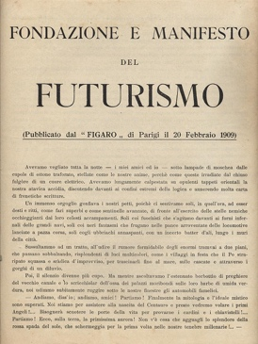
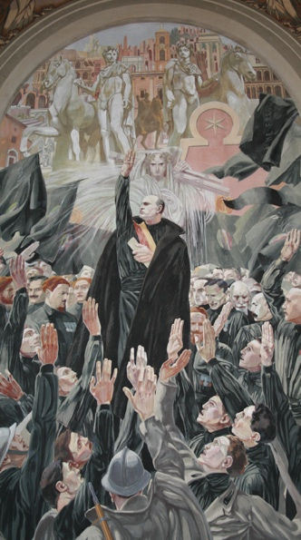
After a short break we heard from two university research projects and their work with schools. Professor Giuliana Pieri introduced two projects in schools which reflected the work of ‘Interdisciplinary Italy’. David Brown of Farnborough Sixth Form College described work in which students collaborated with a school in Ragusa on a project examining differences between perceptions of fascism between English and Italian students. The project has allowed students of History from Farnborough to talk with students from a part of Italy that was directly affected by fascist rule and has been important in bringing students from different parts of Europe together to explore and discuss history, politics and their own family's’ experiences during World War Two. Thomas Cook from Queen Margaret’s, York described a History of Art project on Futurism beginning with the study of Marinetti’s Futurist Manifesto and going on to look at work by Boccioni and other artists. He particularly stressed the opportunities for intersection between history of art and literature in French, Italian and English. Thereafter, Professor Charles Burdett talked about the ‘Transnationalising Modern languages project which aims to consider through individual and collective memories the forms of mobility that have defined modern Italian culture with migrant communities in the UK, Australia, South America and East and North Africa. A good idea of what the project is about can be found at www.transnationalmodernlanguages.ac.uk/research-map. Professor Duncan described in some detail the practical work he has been doing with schools in Scotland looking at art and family histories to help students understand history, heritage and culture and develop an understanding of the world by learning about how people live today and in the past.
Fresco from Town Hall in Ragusa

After lunch, we held a session on resources for teaching Italian in schools in the course of which different teachers (Lucy Edge, Presdales Schools, High Michell, Hockerill Anglo-European College, Jane Briggs, Dulwich College and Marcella Oliviero, Bristol University) introduced ideas for use at different levels and courses. This proved very popular and allowed for a rich exchange of ideas. Feedback suggested that this is an area which could be developed usefully in future meetings.

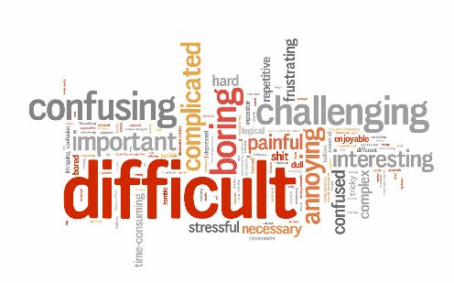
This was followed by a very entertaining talk by Enza Siciliano-Verruccio of Reading University provocatively entitled Grammar?!? F***! Adventures in Italian grammar teaching in which she described her work to encourage students to revised their rather negative views of grammar using different media and peer-to peer teaching and assessment, encouraging independent learning and demonstrating how this can radically alter students’ attitudes to grammar learning. For those interested, this is a Wordle of reactions from students in 2015:
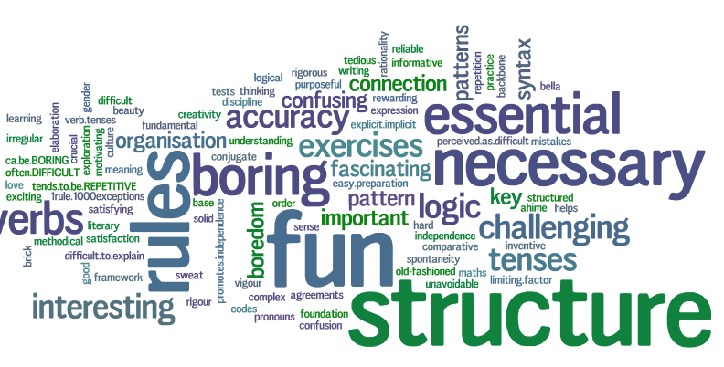
and another based on post-it notes circulated among teachers during before the start of the talk:

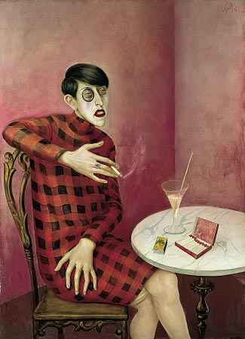
Continuing the theme of interdisciplinarity, Professor Emanuela Tandello of Oxford University presented a talk which reminded us of Pirandello’s view of language a failing tool for communication and how both Pirandello’s novels and his novelle are profoundly image-related, After observing that Pirandello is believed to have seen, and been profoundly influenced by, Fritz Lang’s film Metropolis, she went on to discuss the likely influence on the author of several works by the German artist Otto Dix during his self-imposed exile in Berlin 1930. It was noted in particular that, although there is no proof he saw the painting, the subject of Dix’s 1926 portrait of the sexually ambiguous journalist Sylvia von Harden seems to bear a strong resemblance to the protagonist of Pirandello’s Come tu me voi.

Altogether the day provided a welcome opportunity for teachers of Italian to meet, listen to some stimulating and useful talks and discuss ideas. It is hoped that it may all lead to more regular meetings and opportunities for sharing resources in the future.

Many thanks to ISMLA, The Society for Italian Studies, and the Italian Cultural Institute for their support.

Materials and presentations from the day can be found on the Society for Italian Studies website at http://italianstudies.org.uk/links-and-resources/choose-italian-day.

Peter Langdale, North London Collegiate School.

