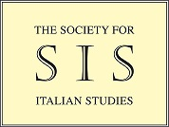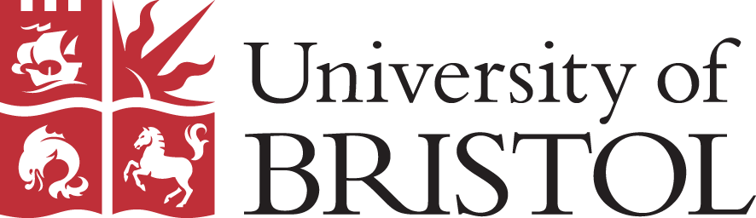

The Society for Italian Studies Postgraduate Conference

The Verdon-Smith Room, Royal Fort House, University of Bristol
Friday 24th November 2017

9am | Registration  Opening remarks (Francesco Goglia: SIS Postgraduate Staff Representative)
9.30am | Panel 1  Cultural Encounters in the Italian Renaissance  Paolo Gattavari (UCL)  Lucian, Aristotle and Aesop in Dialogue: Fusion of Traditions in Pandolfo Collenuccio’s Apologues  Marta Balzi (University of Bristol) Fabio Marretti’s Metamorfosi: The encounter of Italian and Latin on the page  Vittoria Fallanca (University of Oxford)  Drawing Parallels across Renaissance Art Practices: Disegno and Dessein
10.40am | Coffee
11am | Keynote lecture  Dr Guyda Armstrong (University of Manchester)  Multilingual contacts in early modern book-objects
12pm | Comfort Break
12.10pm | Panel 2  Linguistic Encounters  Elena Gerola West (University of Bristol)  Einaudi, Life-writing in Non-Standard Italian and Class: Publishing Vincenzo Rabito’s Memoir Terra matta  Maddalena Moretti (University of Leeds)  The encounter with the other: the deus ex machina of Pasolini’s oeuvre
1pm | Lunch
2pm | Keynote lecture  Dr Jennifer Burns (University of Warwick)  Cross-cultural thinking, and thinking cross-culturally: Theory and practice across borders
3pm | Comfort break
3.10pm | Panel 3  Italian Migration and Cultural Exchange  Claudia Dellacasa (Durham University) Contacts between Japanese Culture and Italian Literature in the Second Half of the Twentieth Century  Olga Hajduk (The Institute of Art of the Polish Academy of Sciences)  Between Poland and Italy: The Tedaldi and Gucci families in the Renaissance period. Networks, patronage and identity.  Marta Pozzolo (University of Reading) Carlo Dionisotti e Luigi Meneghello dall'Italia all'Inghilterra (1947-1980). Intellettuali tra due culture.
4.20pm | Coffee
4.40pm | Panel 4  Italy and the British Isles: Encounters in Literature and Theatre  Emanuela Caffé (UCD)  Cross-cultural echoes: Woolf’s influence on Ferrante  Giulia Abbadessa (Centro Nazionale delle Ricerche)  La letteratura inglese nelle opere di Leopardi: Shakespeare, Milton, Byron  Zsuzsanna Balázs (The National University of Ireland, Galway) Gender and Authority in Luigi Pirandello’s and W. B. Yeats’s Late Plays, and the Influence of Italian Fascism
5.50pm | Closing remarks

Registration for the conference closes on the 21st of November
Registration link:
https://www.eventbrite.co.uk/e/the-sis-pg-conference-cross-cultural-encounters-tickets-39688939687

