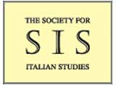 | The Society for Italian Studies  Registered Charity no. 313786

The Honorary Treasurer: Dr Tristan Kay
School of Modern Languages
University of Bristol
17 Woodland Road
Bristol BS8 1TE
Tristan.kay@bristol.ac.uk

CONFERENCE EXPENSES CLAIM FORM

Name:

Address:

E-mail:

UK bank account number and sort code:

Date of claim:

Please indicate the purpose for which expenses are being claimed,
attach receipts or tickets, and return to the Treasurer at the above address.

Date | Details of Claim | Expenses (£)
 | Total = | £

